Eudald Garrofé, Miquel Suau, Bernat Casañas

Aquest document inclou informació sobre totes les funcions implementades per tal d’acomplir l’objectiu requerit en el Projecte.  
Proporcionem una breu descripció sobre cada funció, els seus inputs i outputs.

<https://github.com/MayKoder/MATH_2_Matlab_Project>

Functions paper

Project Matlab – Math II

Functions Paper

Project matlab – math ii

# Update purpose functions

The following described functions share the same purpose, they are called each time the cube gets redrawn during the Redraw function. Its purpose is to modify its own type of representation of the matrix of the cube and show the values in screen.

**Update RotMat**

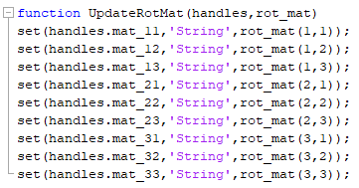

* Purpose: The purpose of this function is to modify the rotation matrix panel each time we redraw the cube through dragging it with our mouse.
* Inputs: Gets the current handles and the rotation matrix contained in the cube.
* Outputs: It has no outputs, simply modifies the static numbers contained in the rotation matrix panel in order that we can see them.

**Update Quaternion**

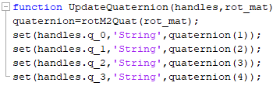

* Purpose: The purpose of this function is to modify the quaternion angular and vectorial part each time we redraw the cube through dragging it with our mouse. Gives use of the rotM2Quat function in order to perform the transformation from a rotation matrix to a quaternion.
* Inputs: Gets the current handles and the rotation matrix contained in the cube.
* Outputs: It has no outputs, simply modifies the editable numbers contained in the quaternion panel in order that we can see them.

**Update EAA**

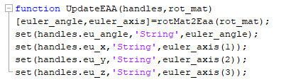

* Purpose: The purpose of this function is to using the rotMat2Eaa function transform the matrix contained in the cube into the principal Euler angle and axis and showing them each time we Redraw the cube.
* Inputs: Gets the current handles and the rotation matrix contained in the cube.
* Outputs: It has no outputs; it modifies the editable text strings for the Principal Euler angle and axis panel in order to see them.

**Update RotVec**

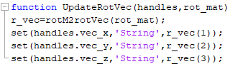

* Purpose: The purpose of this function is to using the rotM2rotVec function transform the matrix contained in the cube into the Rotation Vector and assigning this values to the Rotation Vector panel each time we modify the cube.
* Inputs: Gets the current handles and the rotation matrix contained in the cube.
* Outputs: It has no outputs; it modifies the editable text strings for the Rotation Vector panel in order to see them.

**UpdateEA**

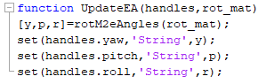

* Purpose: The purpose of this function is to using the rotM2reAngle function transform the matrix contained in the cube into the three Euler angles and assigning this values to the Euler angles panel each time we modify the cube.
* Inputs: Gets the current handles and the rotation matrix contained in the cube.
* Outputs: It has no outputs; it modifies the editable text strings for the Euler Angles panel in order to see them.

# Transformation purpose functions

For these functions its purpose is to transform an inputted matrix into another kind of rotation method.

These have been used in the functions explained before.

**RotM2Quat**

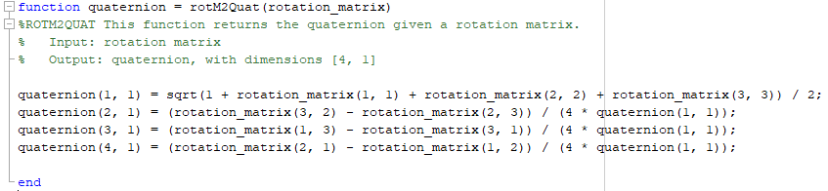

* Purpose: This function modifies a rotation matrix method into a quaternion based method.
* Inputs: Gets the matrix to be transformed.
* Outputs: Returns the quaternion constructed from the matrix.

**RotMat2Eaa**

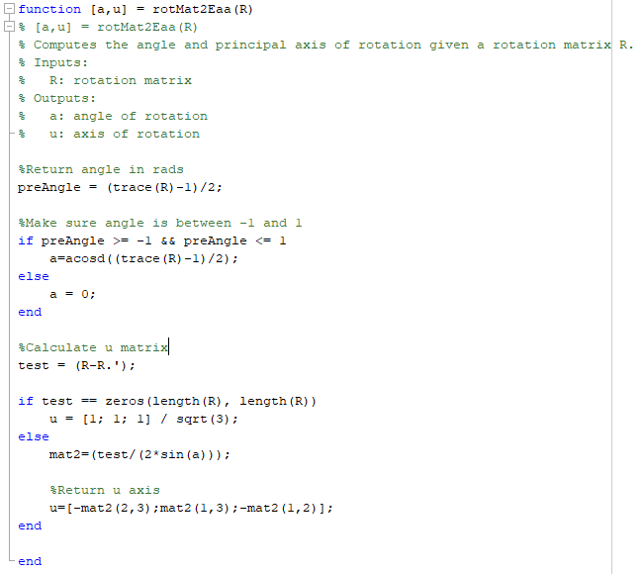

* Purpose: This function modifies a rotation matrix method into a Principal euler angle and axis based method.
* Inputs: Gets the matrix to be transformed.
* Outputs: Returns the Euler’s principal angle and axis constructed from the matrix.

**RotM2rotVec**

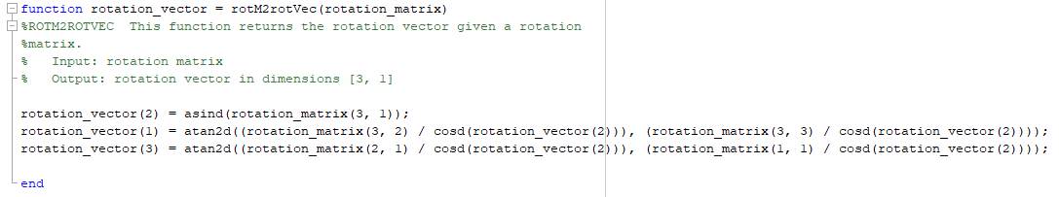

* Purpose: This function modifies a rotation matrix method into a Rotation Vector based method.
* Inputs: Gets the matrix to be transformed.
* Outputs: Returns the Rotation Vector constructed from the matrix.

**RotM2eAngles**

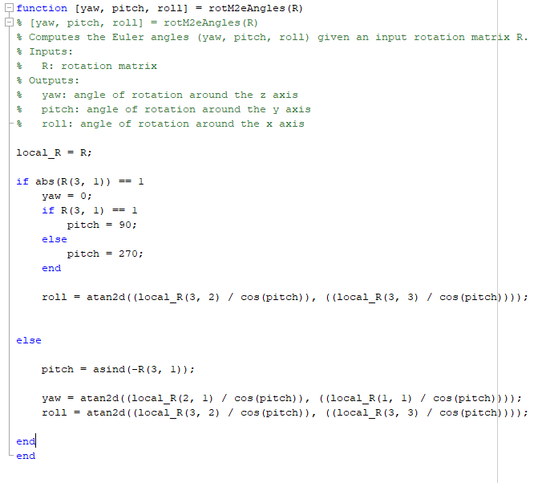

* Purpose: This function modifies a rotation matrix method into a Euler Angles based method.
* Inputs: Gets the matrix to be transformed.
* Outputs: Returns the three Euler Angles pitch, roll and yaw constructed from the matrix.

**RotQua2M**

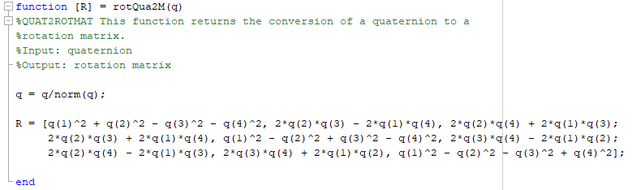

* Purpose: This function creates a rotation matrix from a quaternion.
* Inputs: Gets the quaternion.
* Outputs: Returns the rotation matrix.

**eAngles2rotM**

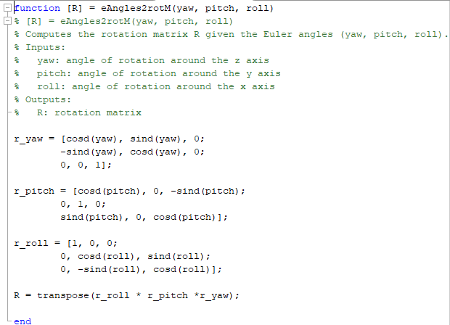

* Purpose: This function creates a rotation matrix from the three Euler angles.
* Inputs: Gets three angles
* Outputs: Returns the rotation matrix.

**Eaa2RotMat**

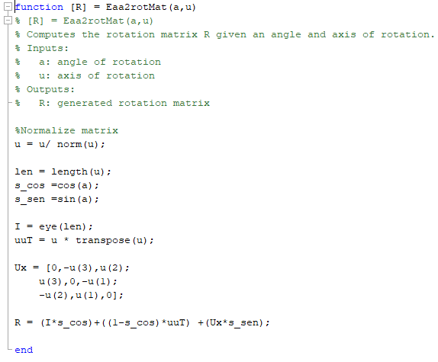

* Purpose: This function creates a rotation matrix from the three the principal Euler angle and axis
* Inputs: Gets an angle and a vector.
* Outputs: Returns the rotation matrix.

**rotVec2rotMat**

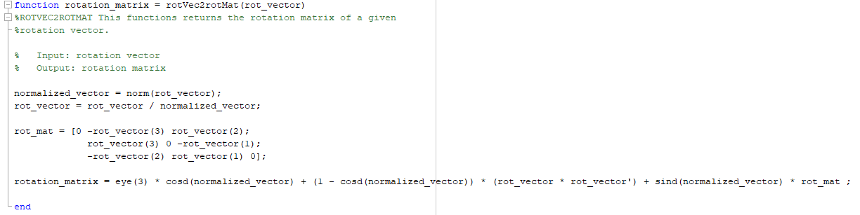

* Purpose: This function creates a rotation matrix from the three a rotation vector.
* Inputs: Gets a vector.
* Outputs: Returns the rotation matrix.

# Push Button Functions

The following functions are the ones that get triggered once a tagged button is pushed.

**Reset**

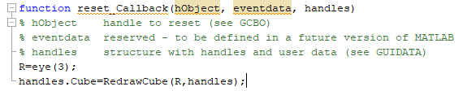

* Purpose: This function has the purpose of restarting the matrix of the cube using a defined identity matrix and sending it to redraw the cube from it.
* Inputs: Recibes the needed parameters that Matlab requires to perform a callback with a button.
* Outputs: It has no outputs, simply performs a reset on the cube, including the whole other rotation methods on the panels that directly depend on the cube matrix.­

**Quaternion**

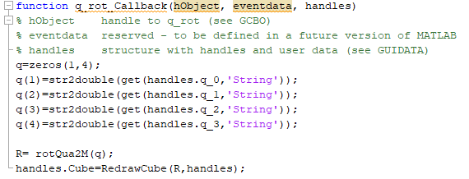

* Purpose: This function gets the current values of the editable text boxes of the quaternion panel and creates a rotation matrix from them, later it passes the matrix to redraw de cube.
* Inputs: Recibes the needed parameters that Matlab requires to perform a callback with a button.
* Outputs: It has no outputs.

**Principal Euler Angle and Axis**

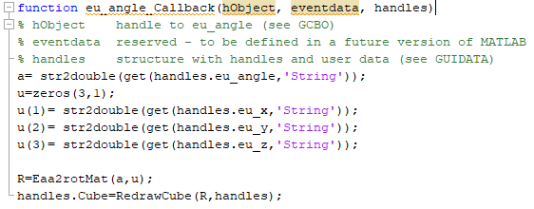

* Purpose: This function gets the current values of the editable text boxes of the euler principal angle and axis panel and creates a rotation matrix from them, later it passes the matrix to redraw de cube.
* Inputs: Recibes the needed parameters that Matlab requires to perform a callback with a button.
* Outputs: It has no outputs.

**Euler Angle**

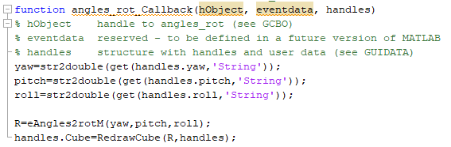

* Purpose: This function gets the current values of the editable text boxes of the euler angles panel and creates a rotation matrix from them, later it passes the matrix to redraw de cube.
* Inputs: Recibes the needed parameters that Matlab requires to perform a callback with a button.
* Outputs: It has no outputs.

**Rotation Vector**

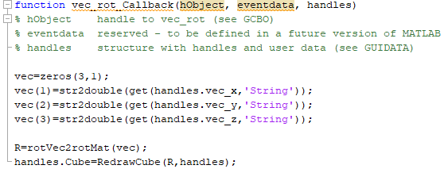

* Purpose: This function gets the current values of the editable text boxes of the rotation vector panel and creates a rotation matrix from them, later it passes the matrix to redraw de cube.
* Inputs: Recibes the needed parameters that Matlab requires to perform a callback with a button.
* Outputs: It has no outputs.